IENE 5 - NATIONAL SEMINAR IN CYPRUS

The Cyprus National Seminars was organized and implemented on the 30th of June 2017, at the Poseidonia Beach Hotel in Limassol, Cyprus.
The The seminar lasted 6 hours and the topics included:
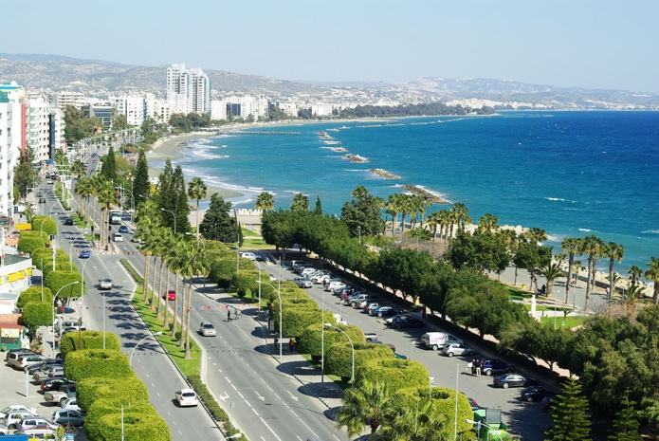
- Presentation of the project activities and outputs
- Personal experiences of students who attended the MOOC
- Presentation of the MOOC platform and a workshop with selected MOOC activities
- Discussion to exchange ideas on ways to use the project outputs
National Seminar aimed to present the project activities and outputs and optimise the value of the project results, and maximise the potential of activities so that the project results to be used to the best possible advantage both within the partners’ organisations and beyond them.
Thirty-three (33) persons - mainly nurses- from all country regions, attended the national seminar in Cyprus.
The Cyprus National Seminar was successful, with positive feedback from the participants.

AUTHOR: CYPRUS UNIVERSITY OF TECHNOLOGY
Cyprus, August 2017

